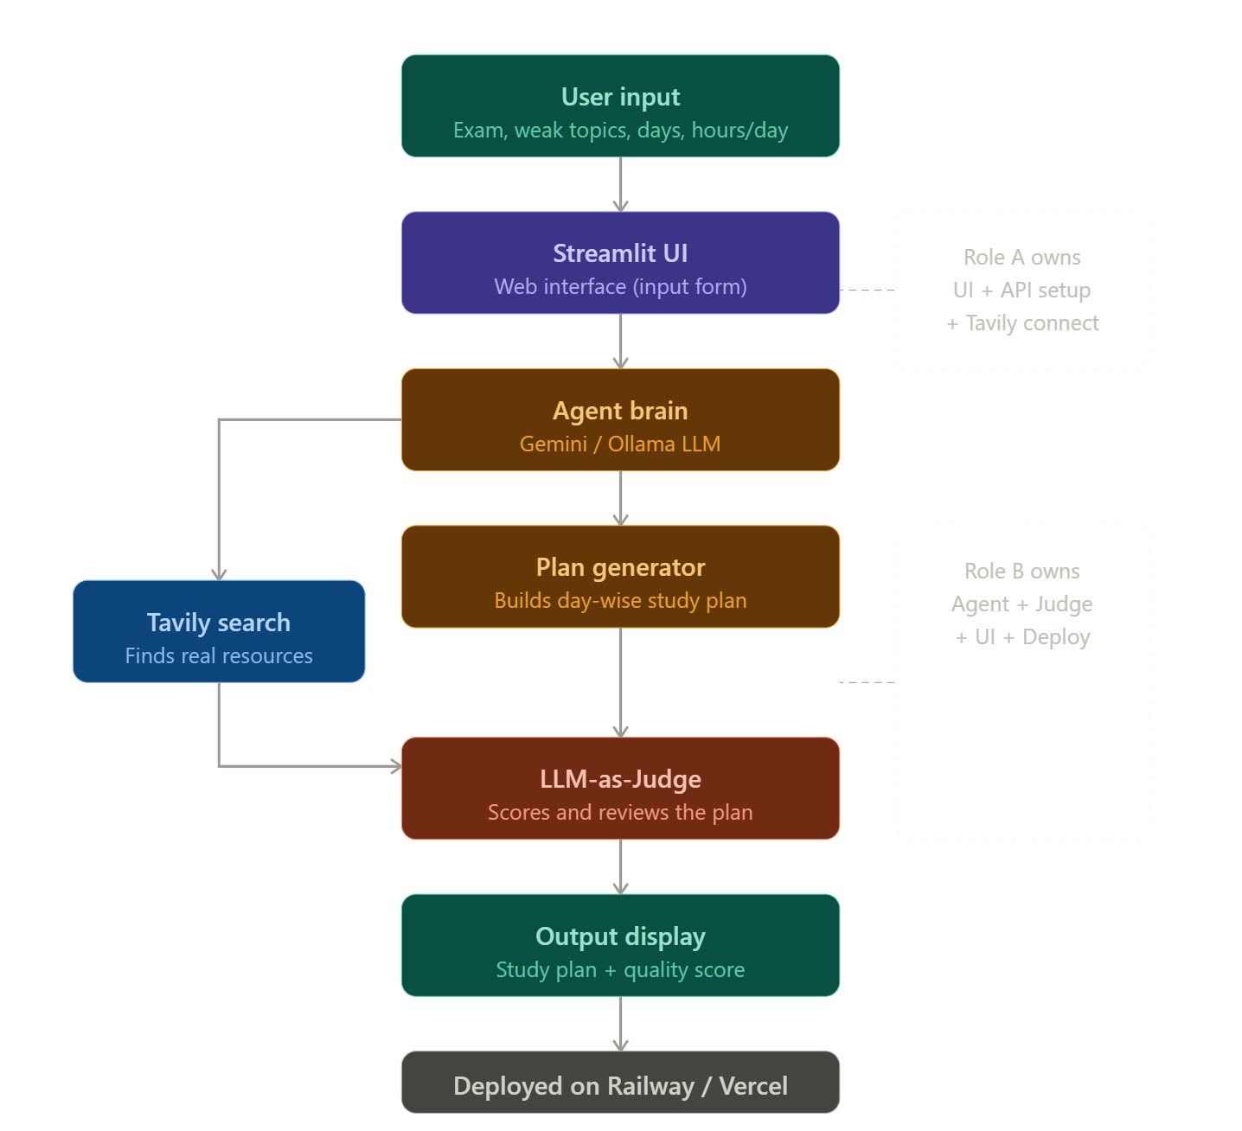
The flow top to bottom:
- User input — student fills in exam name, weak topics, days left, hours per day
- Streamlit UI — the webpage that takes the input
- Agent brain — the Gemini/Ollama LLM that thinks and decides what to do
- Tavily search — agent sends a search request here to find real study resources from the internet
- Plan generator — uses the search results + LLM reasoning to build a day-wise plan
- LLM-as-Judge — a second AI call that reads the plan and gives it a quality score
- Output display — shows the final plan + score to the student
- Railway/Vercel — the whole app is live on the internet via this

